**PROJECT 3**

**Deliverables #1: March 16th – Plan, Design and Research**

**Deliverables #2: March 23rd – Ready MVP (Working App!), Mini-Presentation**

**Deliverables #3: March 30th – Project Polish, Functionality Push, Final Plan**

**Final Presentation (April 6) – Presentation Time!**

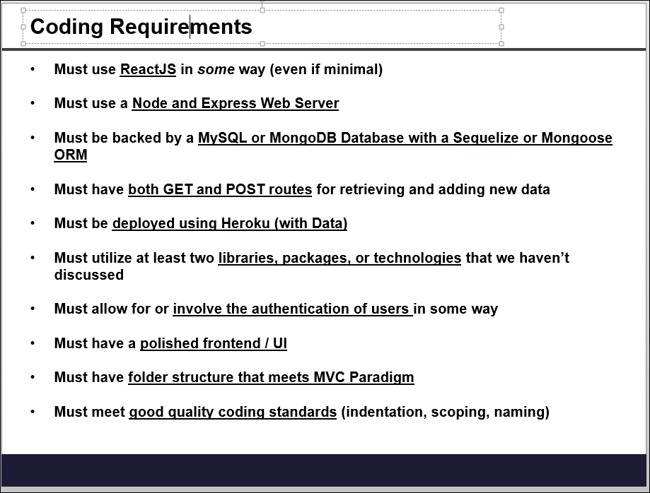

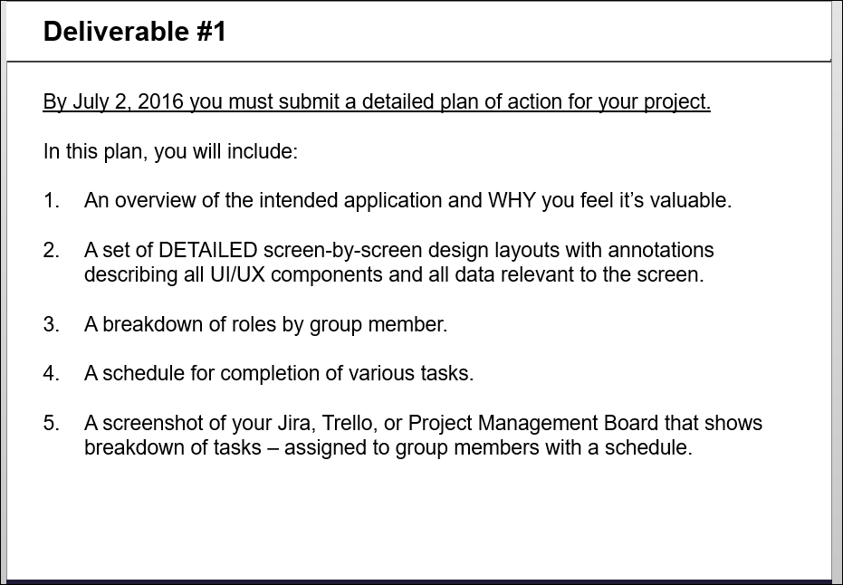

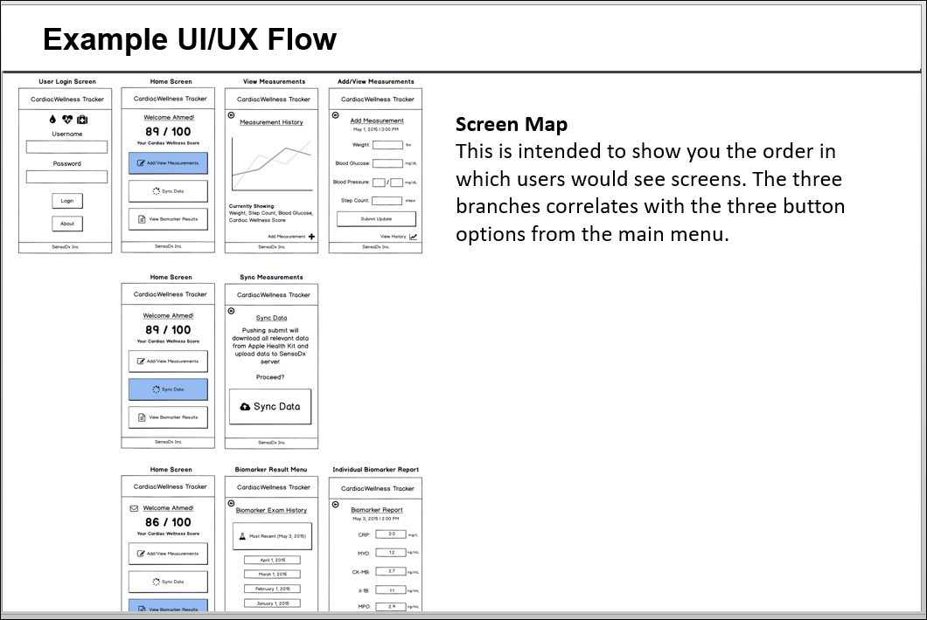

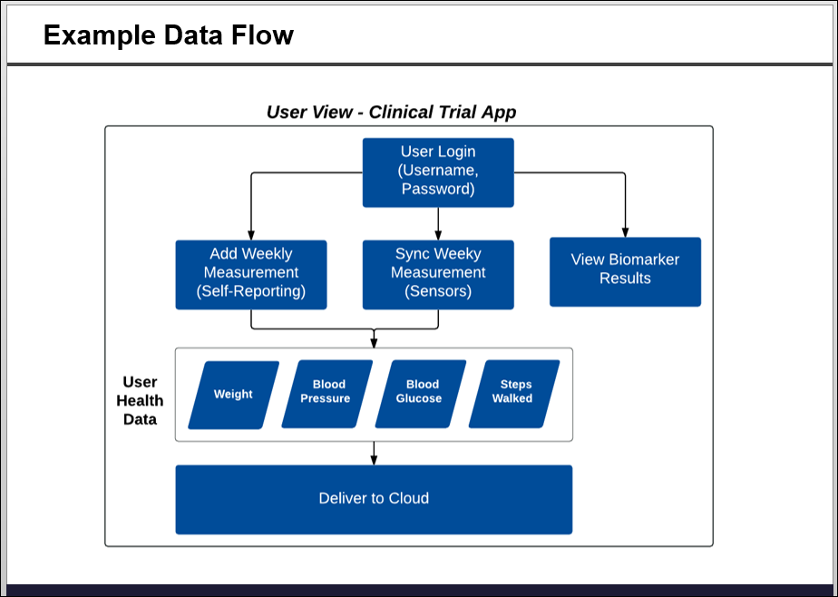

**SeeCurrent**

**Seller**

Login – store customer data in mongodb

Store images and offers in mongodb

Split into groups – Beauty/Entertainment/etc.

Offer an input screen for new ads?? New text?? React

NPM click tracking

**Buyer**

Login – store customer data in mongodb

**Voting App**

1. Login

2. Find local representatives

3. Check voting record

**Google Civic Information API**

<https://developers.google.com/civic-information/docs/using_api>

<https://www.gettothepolls.com/>

**ProPublica Congress API:**

KEY: 4q0wM0CfJMh4PUJHYOlQTBUSun5I1rXSa92ztgzV

**Images and bios of Representatives:**

<https://github.com/unitedstates/images> or

<https://aapi.io/api-directory/USGovernmentPublishingOfficeGPO_govinfo.gov_LinkServiceAPI_0.5.0/>

